Operators

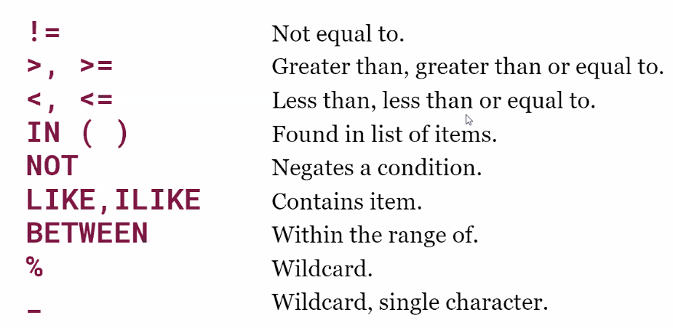

|  |  |
| --- | --- |
| **LIKE Operator** | **Description** |
| WHERE CustomerName LIKE 'a%' | Finds any values that start with "a" |
| WHERE CustomerName LIKE '%a' | Finds any values that end with "a" |
| WHERE CustomerName LIKE '%or%' | Finds any values that have "or" in any position |
| WHERE CustomerName LIKE '_r%' | Finds any values that have "r" in the second position |
| WHERE CustomerName LIKE 'a_%' | Finds any values that start with "a" and are at least 2 characters in length |
| WHERE CustomerName LIKE 'a__%' | Finds any values that start with "a" and are at least 3 characters in length |
| WHERE ContactName LIKE 'a%o' | Finds any values that start with "a" and ends with "o" |

Example Questions (and answers)

Which products have a case cost of more than $100?

Answer (highlight me): 3730 (rows)

SELECT count(distinct item_no)

FROM products

WHERE case_cost > 100;

Which tequilas have a case cost of more than $100?

Answer (highlight me): 422 (rows)

SELECT count(distinct item_no)

FROM products

WHERE category_name ilike '%tequila%'

AND case_cost > 100;

Which tequilas or scotch whiskies have a case cost of more than $100?

Answer (highlight me): 687 (rows)

SELECT count(distinct item_no)

FROM products

WHERE category_name IN ('TEQUILA', 'SCOTCH WHISKIES')

AND case_cost > 100;

Which tequilas or scotch whiskies have a case cost between $100 and $120?

Answer (highlight me): 107 (rows)

SELECT count(distinct item_no)

FROM products

WHERE category_name IN ('TEQUILA', 'SCOTCH WHISKIES')

AND case_cost between 100 and 120;

Which whiskies of any kind cost more than $100?

Answer (highlight me): 819 (rows)

SELECT count(distinct item_no)

FROM products

WHERE category_name ilike '%whiskies%'

AND case_cost > 100;

Which whiskies of any kind cost between $100 and $150?

Answer (highlight me): 400 rows

SELECT count(distinct item_no)

FROM products

WHERE category_name ilike '%whiskies%'

AND case_cost between 100 and 150;

Which products, excluding tequilas, cost between $100 and $120?

Answer (highlight me): 976

SELECT count(distinct item_no)

FROM products

WHERE category_name != 'TEQUILA'

AND case_cost between 100 and 120;